Ideation Phase
Brainstorm & Idea Prioritization Template

Date | 24 Feb 2026
Team ID | LTVIP2026TMIDS55906
Project Name | Strategic Product Placement Analysis: Unveiling Sales Impact with Tableau Visualization
Maximum Marks | 4 Marks

Brainstorm & Idea Prioritization Template:
Brainstorming provides a free and open environment that encourages everyone within a team to participate in the creative thinking process that leads to problem solving. Prioritizing volume over value, out-of-the-box ideas are welcome and built upon, and all participants are encouraged to collaborate, helping each other develop a rich amount of creative solutions.
Use this template in your own brainstorming sessions so your team can unleash their imagination and start shaping concepts even if you're not sitting in the same room.
Reference: https://www.mural.co/templates/brainstorm-and-idea-prioritization
Step-1: Team Gathering, Collaboration and Select the Problem Statement :
Problem Statement Selected:
Retail and e-commerce businesses often struggle to understand how the placement of products within stores or on digital storefronts influences sales performance. Without proper analytics, decisions around shelf placement, category grouping, and promotional positioning remain guess-based rather than data-driven.
Objective of the Project:
To analyze product placement strategies and identify which shelf positions, zones, or display layouts lead to maximum sales. The project aims to deliver a Tableau-based interactive dashboard to visualize patterns, trends, and high-performing product positions.
Key Discussion Points During Team Collaboration:
- Many retailers fail to measure placement impact despite collecting sales data.
- Understanding placement effectiveness can boost revenue significantly.
- Visualization using Tableau can make insights more interactive and decision-friendly.
- Project can create real-world value for retail domains, supermarkets, and online platforms.
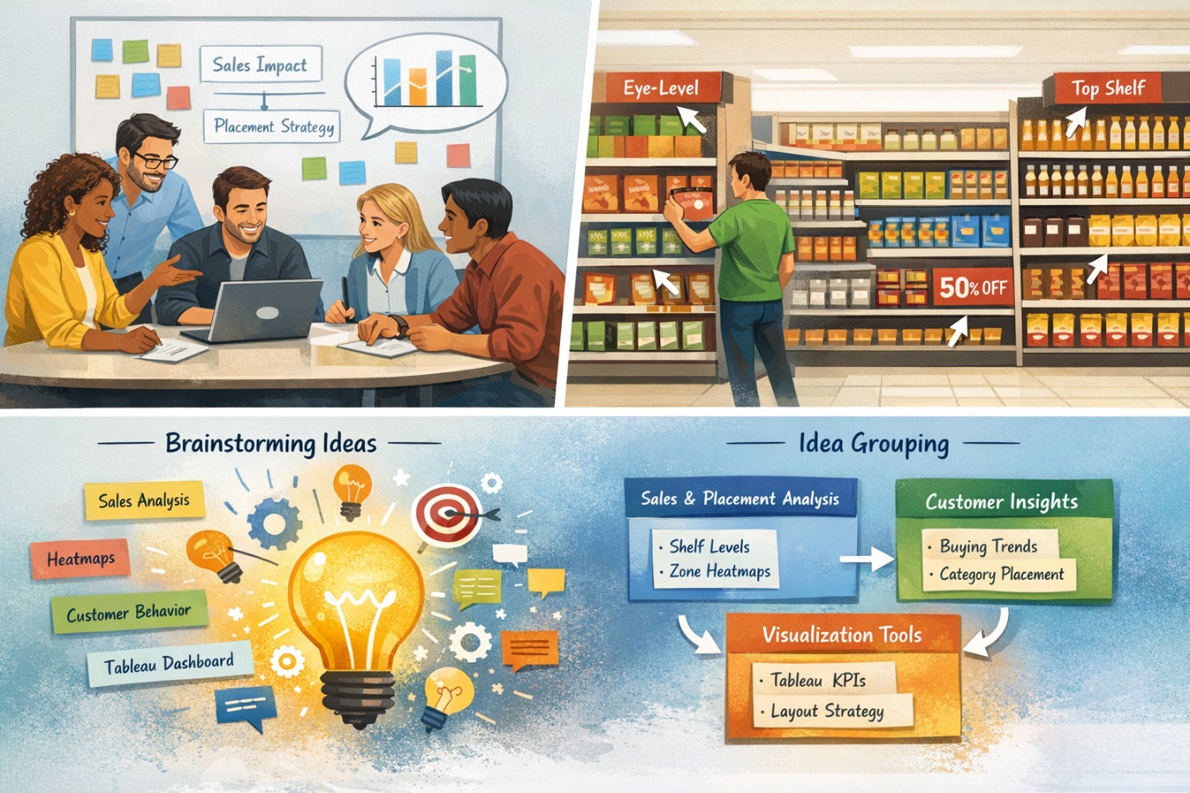

Step-2: Brainstorm, Idea Listing and Grouping :
Raw Ideas Generated:
- Analyze sales trends based on shelf levels (top, eye-level, bottom).
- Compare sales between end-cap displays vs normal shelves.
- Identify customer buying patterns influenced by product adjacency.
- Visualize heatmaps showing high-selling store zones.
- Determine correlation between product category placement and sales lift.
- Integrate promotional placement impact (discount vs location).
- Suggest optimal product arrangement for maximum visibility.
- Build an interactive Tableau dashboard for real-time visualization.
- Use KPIs like conversion rate, sales uplift, customer footfall patterns.
- Recommend model for ideal store layout using insights.
Grouped Ideas
Group A – Sales & Placement Analysis
- Shelf-level sales evaluation
- Zone-based heatmaps
- End-cap vs regular shelf comparison
- Product adjacency impact analysis
Group B – Customer Behavior Insights
- Buying trend visualization
- Category-wise placement effectiveness
- Seasonal impact on placement
Group C – Visualization & Decision Tools
- Tableau dashboards
- Key metrics and KPIs
- Recommended layout strategies
- Interactive filters for store managers
Step-3: Idea Prioritization :
Prioritization Criteria Used:
- Feasibility
- Data availability
- Value creation for retailers
- Ease of visualization in Tableau
- Impact on decision-making
Final Prioritized Solution:
The team will focus on creating a comprehensive Tableau dashboard that reveals the impact of product placement on sales using:
- Shelf-level performance charts
- Zone heatmaps
- End-cap effectiveness analysis
- Category & adjacency insights
- KPIs for quick decision-making
The goal is to deliver an actionable visualization system enabling businesses to optimize product placement and maximize sales.

